Experiment 5: Implement a firewall for an organization.

Introduction (iptables):
iptables acts as a packet filter and firewall that examines and directs traffic based on port, protocol and other criteria.
- The Filter table is the most frequently used one. It acts as a bouncer, deciding who gets in and out of your network. It has the following default chains:
When a packet matches a rule, it is given a target, which can be another chain or one of these special values:
- ACCEPT – will allow the packet to pass through.
- DROP – will not let the packet pass through.
- RETURN – stops the packet from traversing through a chain and tell it to go back to the previous chain.
In this iptables one of the default tables is filter. It consists of three chains:
- INPUT – controls incoming packets to the server.
- FORWARD – filters incoming packets that will be forwarded somewhere else.
- OUTPUT – filter packets that are going out from your server.

Iptables filters packets based on:
- Tables: Tables are files that join similar actions. A table consists of several chains.
- Chains: A chain is a string of rules. When a packet is received, iptables finds the appropriate table, then runs it through the chain of rules until it finds a match.
- Rules: A rule is a statement that tells the system what to do with a packet. Rules can block one type of packet, or forward another type of packet. The outcome, where a packet is sent, is called a target.
- Targets: A target is a decision of what to do with a packet. Typically, this is to accept it, drop it, or reject it (which sends an error back to the sender).

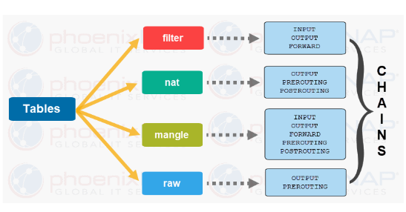

Procedure:
$sudo service apache2 start
-$ sudo service mysql start

Check IP address in kali linux : By using command ( ifconfig )
Check VMnet8 IP address in windows (cmd )

Launch the web browser and run 192.168.192.130(kali linux IP address)

Step-1: By default, iptables does not have any rules defined. verify this by typing the following
command:
sudo iptables-L
Step-2: Deleting all rules
sudo iptables -F
Step-3:DROP A PACKET FROM SPECIFIC SOURCE
sudo iptables -A INPUT -s 192.168.192.1 -j DROP
1. -A option instructs iptables to append the rule to the end of the specified chain (in this case,
the INPUT chain).
2. The -s parameter, along with the IP address (198.51.100.0), indicates the source.
3. Finally, the -j parameter stands for jump. It specifies the target of the rule and what action will beperformed if the packet is a match.
To unblock:
$ sudo iptables -D INPUT -s 192.168.192.1 -j DROP

Task 2: Block the port numbers

$ sudo iptables -A INPUT -s 192.168.192.1 -p tcp --destination 80 -j DROP
⮚ -A will add or append the rule to the end of the chain.
⮚ INPUT will add the rule to the table.
⮚ DROP means the packets are discarded.
⮚ -p tcp means the rule will only drop TCP packets.
⮚ --destination-port 80 filters packets targeted to port 80

To unblock :
$ sudo iptables -D INPUT -s 192.168.192.1 -p tcp --destination-port -j DROP

Observation:
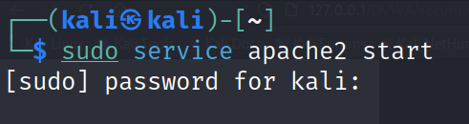
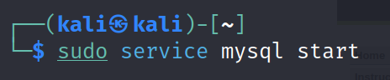
Check ipaddress in kali linux
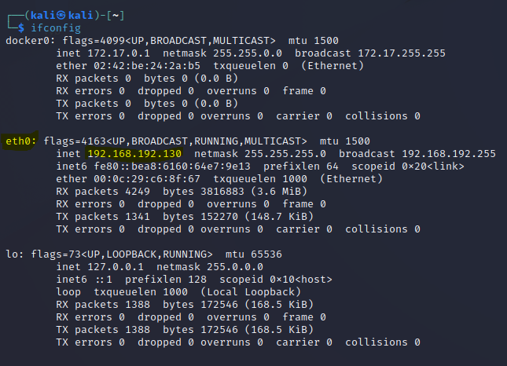

Check VMnet8 ip address in windows(cmd)
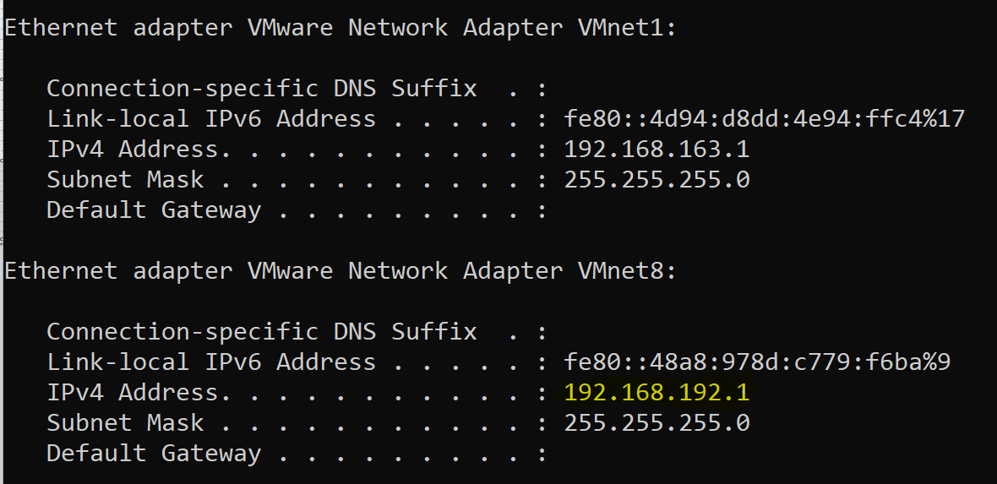

Launch the web browser and run 192.168.192.130(kali linux IP address)
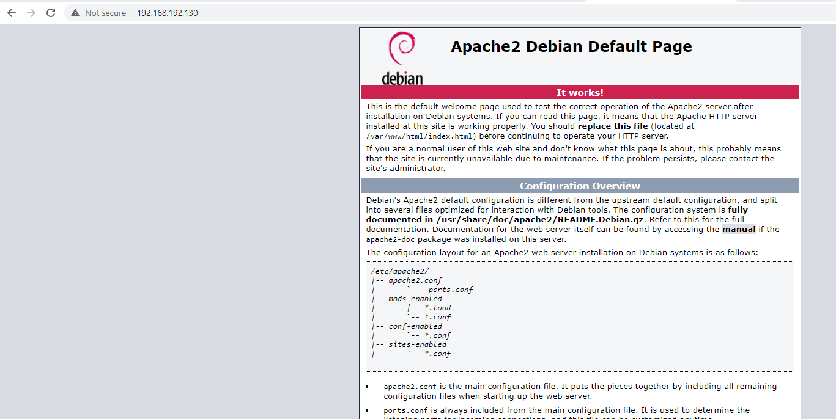

Step-1: By default, iptables does not have any rules defined. verify this by typing the following command:
sudo iptables -L

Step-2: Deleting all rules
sudo iptables -F

Step-3:DROP A PACKET FROM SPECIFIC SOURCE
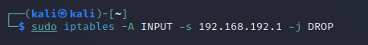
- -A option instructs iptables to append the rule to the end of the specified chain (in this case, the INPUT chain).
- The -s parameter, along with the IP address (198.51.100.0), indicates the source.
- Finally, the -j parameter stands for jump. It specifies the target of the rule and what action will be performed if the packet is a match.

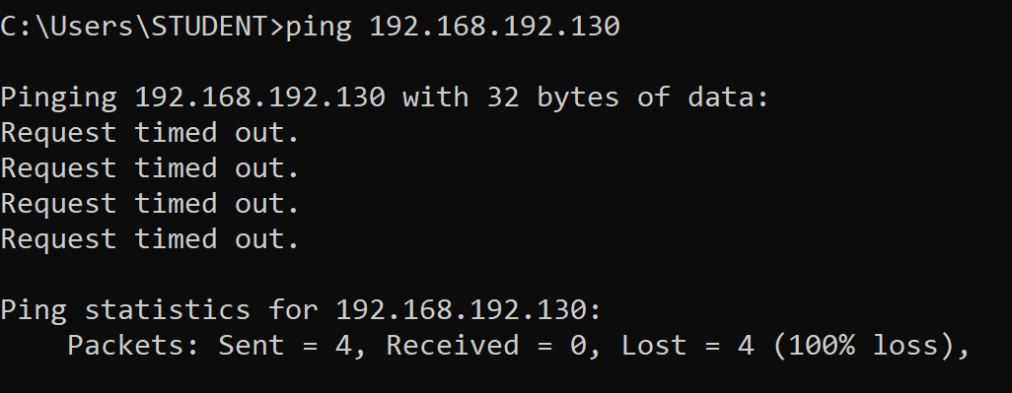
To unblock:
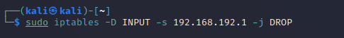
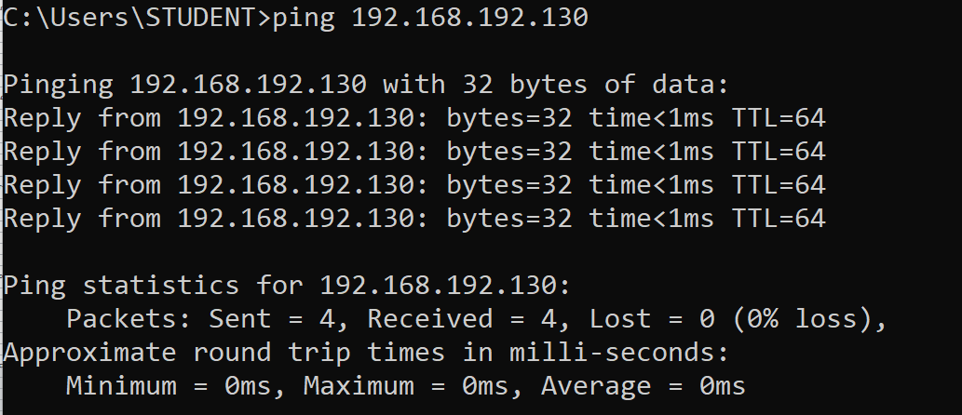
Task 2: Block the port numbers
- -A will add or append the rule to the end of the chain.
- INPUT will add the rule to the table.
- DROP means the packets are discarded.
- -p tcp means the rule will only drop TCP packets.
- --destination-port 80 filters packets targeted to port 80
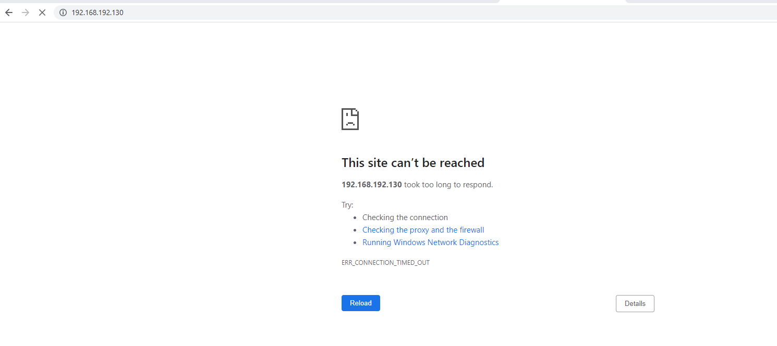
To unblock
